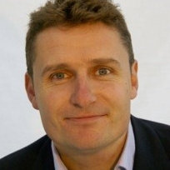

Alastair Hill PCC
Consultant and Coach

Based in the UK, Alastair consults and coaches in English

Profile
Alastair is a solution-focused executive coach. His style suits organisations and clients that like to make rapid progress – transforming their learning into action in double quick time. His approach is to focus on connecting his clients thinking (Head) and how they’re being (Heart) to their behaviours and actions (Hands). This allows them to achieve their goals and, vitally, make deep-seated sustainable change.
One of Alastair’s key coaching strengths, which ensures great results, is the ability to balance empathy and support with the right amount of challenge and direct feedback, to suit a situation and an individual. His natural impartiality and levelheadedness are qualities that guide the content of his questions, allowing his clients to gain all-round awareness and clarity of a situation. This quickly leads to well-informed decisions and action.
Where relevant and appropriate Alastair introduces tools, models and techniques to complement the coaching process e.g. 360° Feedback, Emotional Intelligence questionnaires, NLP, Cognitive Behavioural Coaching techniques, leadership models and techniques etc.

In addition to 1-2-1 coaching Alastair develops and facilitates leadership development training and employee engagement initiatives. The core philosophy running through his programmes is the introduction of emotional connection to move leadership from transactional to transformational.
Specialist Areas of Expertise
- Improving Working Relationships
- Building Confidence and Competence
- Managing Change
- Career Development
Alastair has a successful track record in delivering
- 1:1 leadership coaching
- Employee engagement

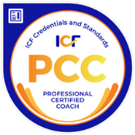
Profile: Alastair Hill PCC
Corporate Experience
Alastair has helped over 200 executives and delivered over 1100 hours of coaching across various sectors including banking, finance, FMCG, marketing, media and manufacturing.
Education & Training
- Certified Professional Coach accredited by the International Coach Federation (PCC)
- Certified Confidence Cognitive Behavioural Coach (CCG)
- Licensed Career Counsellor (CCS)
- Level 1a Certified Facilitator for the Nine Conversations in Leadership, Purposeful Teams and the Heart of Leadership
- Certified Neuro-Linguistic Programming (NLP) Practitioner
Memberships
Member of the International Coach Federation and Association for Coaching

