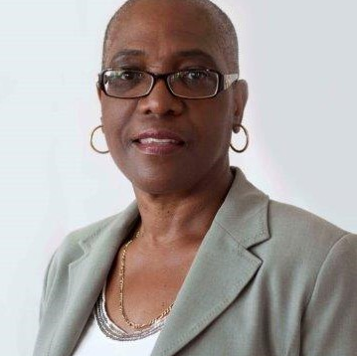

Brenda Van Rossum ACC
Consultant and Coach

Based in Canada, Brenda consults and coaches in English.

Profile
Brenda’s personal style is connecting heart to heart, using intuition, strong listening skills and an agreed upon process of holding you accountable for your goals and outcomes. Throughout this process, she provides a passionate, spirited, innovative, and caring approach to help you make a difference in your life.
As a dynamic leader, Brenda’s leadership vision is working with you to create a place where your strongest voice is heard, your dreams become reality and where you uncover your full potential.
Specialist Areas of Expertise
- Executive Coaching
- Leadership Development
- Organisational Development
- Emotional Intelligence
- Mentoring
- Workshop Facilitation
- Motivational Speaking
- Change Management
- Conflict Resolution
Brenda has a successful track record in delivering
- 1:1 Leadership coaching
- Team Building
- Leadership development
- Employee engagement
- Project Management
- Career counselling
- Customer Satisfaction.

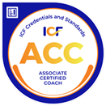
Profile: Brenda Van Rossum ACC
Corporate Experience
Brenda has worked across a range of industries, including Social Services Agencies, ITC, Rehabilitation and Sports Services, the humanitarian sector.
Education & Training
- Associate Certified Coach (International Coach Federation)
- Kids Coaching Connection (Magnificent Creations Limitee)
- Certificate in Coaching Skills for Managers and Directors (York University)
- Performance Coaching in the Workplace (Coach U, Inc. and Seneca College)
- Developing a Strategic Mindset, Executive Education Centre (York University)
- BA in Applied Arts Administration & Information Management (Ryerson University)
- Certificate in Adult Learning (George Brown College)
- Diploma in Business Administration- Accounting (Centennial College)
Memberships
- Member of the International Coach Federation (ICF)
- Member of Bell Canada President’s Club.
Volunteering
Member of the International Coach Federation GTA chapter; The Urban Financial Services Coalition (UFSC) Toronto Chapter; YMCA Greater Toronto since 93.
4+ years a as panel member for Scarborough Youth Justice Committee dealing with first time offenders.
Involved in the Leadership Council of Scarborough YMCA.
Deliver financial literacy skills to youth (Grades 11 and 12) as a Financial Literary Program Mentor for Junior Achievement Central Ontario.

