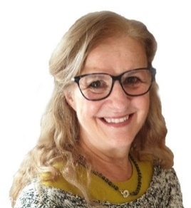

Dr Ewa Rozwadowska
Consultant and Coach

Based in the UK, Ewa consults and coaches in English,
she also speaks Polish

Profile
Ewa uses her ‘real-world’ experience to combine empathy with professional business knowledge, resulting in outcomes tailored specifically to her clients.
Ewa is an award-winning business owner and former dentist, with extensive experience of business development, team motivation and individual career growth. As an experienced coach and mentor, Ewa has worked as an advisor in maintenance of professional standards, compliance, appraisal, and strategy at board level. “I have been where you are. I have experienced challenges and obstacles just like you. We will work together to achieve your business and personal objectives, and navigate challenges of work/life balance, enabling you to think and plan for the future”.
Ewa has a successful track record in delivering change Management, team coaching and one to one coaching. Her specialist areas of expertise are -
- Professional and private healthcare sectors
- Business development
- Leadership
- Team development
- Coaching and Mentoring for individuals
- Communication and collaborative working
- Performance and conflict management
Testimonial
"Ewa helped us focus on what's important for us. After a few sessions, she helped give us a clear mind set and vision for what we want to achieve going forward. We have changed as people and our practice and business have changed with us. Ewa helped, in a few months, what would have taken years without her help.” Dental Practice Owner
Corporate Experience
Ewa has worked across range of sectors including Dentistry, Health, Research, Pharmaceutical and SME business owners.
Education & Training
- Bachelor of Dental Surgery (U. Birmingham)
- FGDP Certificate in Dental Practice Appraisal
- Certificate Coaching & Mentoring (U. Oxford Brookes)
- CMI Level 7 Leadership Coaching & Mentoring
- ICF Cert Coach Supervision/Mentoring
Volunteering: Denplan Excel Quality Assurance Programme Board Member.

