Howard O’Donnell, PCC
Consultant & Coach

Based in France, Howard Coaches and trains in English and
French

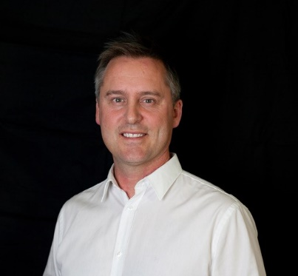

Profile
What is your coaching philosophy – I create ‘light bulb’ moments and support inspirational learning for business professionals
What is your ‘Unique Selling Point’? I’m known for my infectious enthusiasm, playfulness and creative spirit.
I have been responsible for many transformational initiatives including a 160,000 strong leadership development model creation and roll-out, supported young high potentials globally at distinguished business schools, C-suite executives and supporting new flat / trust based organizations.
I have worked with company wide projects as well as lone entrepreneurs and start-ups offering one-2-one coaching, training, action learning solutions as well as seminar and connecting event facilitation and large-scale interventions.
Specialist Areas of Expertise
- Specialist in creating learning journeys that develop talent, company culture and
- leadership at every level.
- Training focussed on experiential ‘Live Learning’
- Executive team coaching and event facilitation
- Leadership development specialist
- Effective communication & presentation skills
- Connecting events facilitator and master of ceremonies
- Strengths and situational based leadership
- Developing coaching skills for managers
- Emotional & relationship intelligence
- Global skills training & project facilitation
Howard has a successful track record in delivering -
- 1:1 leadership coaching
- Team and Group coaching
- Leadership development
- Change management
- Conflict Management

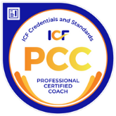
Profile: Howard O’Donnell, PCC
Testimonial
Facilitation :
Howard has been a trusted associate for several years now and has planned and facilitated some excellent team development days for me. He brings infectious enthusiasm and real skill into these important events. He easily creates a genuine engagement within the group and I wouldn't hesitate to work with him again in the future. Thanks Howard!
Alan Woodruff Vice-President Head of A330 Developments at Airbus
Coaching:
I’ve worked alongside Howard and enjoyed the energy and passion he brings to every project. He’s one of those rare people who prepares meticulously (to get the detail right) and then makes his topic look so relaxed in delivery. As a leadership development expert and executive coach I rate him very highly.
Helen Caton-Hughes MA, PCC, Chartered Marketer
Corporate Experience
Howard has worked in a variety of industries and sectors and with global clients including the manufacturing, aeronautic, finance, defence, space, hi-tech, retail and gas and oil sectors. He is a regular guest lecturer at several international business schools and has given key-note speeches and seminar interventions throughout Europe, the U.S and Asia.
Education & Training
- ICF accredited coach to PCC level
- TTI Success Insights qualified trainer – behaviours and motivational drivers
- TTI Success Insights qualified Coach – emotional intelligence
- MPI- certified upAgear team coach
- Airbus Group Leadership University – Certified leadership coach
- Airbus Group Leadership University – Master facilitator including mentoring and onboarding responsibility
Memberships
- Member of International Coach Federation (ICF)
Volunteering
- Local business start-ups in my home town as well as supporting a professional basketball team with strategy consulting and team coaching

