Neil Camacho MBA PCC
Consultant and Coach
Based in Costa Rica, Neil coaches in Spanish, Portuguese and English;
facilitates and trains in Spanish and Portuguese
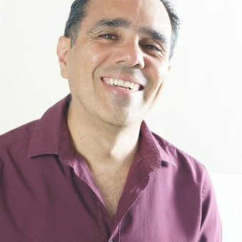

Profile
Neil "enjoys accompanying people so that, through transparency and creativity, they achieve a version of themselves with the happiness, quality of life and success that best suits them." To achieve this, he uses self-knowledge and recognition, through coaching and mentoring, to enhance leadership, innovation, teamwork and above all, "Ikigai" (life purpose). All within a DEIPJ framework (Diversity, Equity, Inclusion, Belonging and Justice).
Some of the topics that he have more hours of experience are: optimization of interpersonal relationships, improvement of work and personal productivity, career development, optimization of communication and, leadership and teamwork. However, in his coaching sessions, any topic will be important, just because it's the client´s topic.
He has lived, studied, or worked for significant periods in Brazil, Costa Rica, Japan, the United Arab Emirates, Peru, Uruguay, Central America, Panama, Ecuador, Colombia, Mexico, and the United States of America.
Part of his professional time is invested in "pro bono" or voluntary work for organizations and people at an international level. One of his most important activities is CÍI LEADERSHIP (Conscious, Inspiring and Innovative), a program that is available on demand. Benziger Thinking Styles Assessment (BTSA), Insight, Clown Esencial and Points of You, are other tools he uses. He has supported in various ways "Yo Emprendedor", an organization that promotes entrepreneurship among young people in Central America; he has supported "Reciclando Sons", an organization that promotes leadership among young people in Brazil. He is part of the "Jovens Lideres" coaching team in Brazil; and has coaching for prisoners and street residents in Guatemala and Costa Rica.
Specialist Areas of Expertise
- Improvement of work and personal productivity
- career development
- communication optimization
- stress & anxiety
- DEIJB
Neil has a successful track record in delivering
- Leadership and teamwork
- Career Development
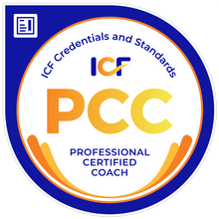
Profile: Neil Camacho MBA PCC
Testimonial
“Neil is a Great Coach who will help you in work-related topics and personal situations as well. He has a well-structured methodology that allowed me to assess all the areas of my life, in professional and personal areas. With his guidance, we established classified goals, key indicators and tracked progress during the coaching sessions. I had a wonderful outcome of improvements in each area, plus a very clear defined "life purpose". These sessions and materials were developed in 2018, and five years later, I still use it for reference and to make retrospective analysis of myself; while I can also use it to help others in my team. Neil's work is wonderful and I certainly recommend him, because he has all the skills set, expertise, professional criteria, business sense and personal values, that anyone would wish to have from an executive coach” –
Roylin Castrillo Sequeira, Sr Vendor Manager, UBER Technologies
Corporate Experience
Neil has worked across a range of industries, including Shared services, banking, pharmaceutical, education, technology, The humanitarian sector, NGO’s such as Plan International and charities working in 3rd world countries. He has coached leaders of the Special Olympics in Latin America through the ICF Foundation
Education & Training
2023 - Professional Recertified Coach (PCC, since 2020)
2022 - Mental Health Coach, Modern Health University
2019 - Executive Coach and Certified Success Coach, Success Unlimited Network
2019 – L3, Points of You
2002 – MBA, INCAE Business School
1995 - Industrial Engineer, University of Costa Rica
Memberships
- Member of the International Coach Federation (ICF)
Volunteering
- ICF, Costa Rica (pro bono coaching for entrepreneurs, prisoners, and students)
- JOVENS LIDERES, Brazil (Coaching for young leaders)
- HOSPITAL MEXICO PALLIATIVE CARE UNIT, Costa Rica (team and individual coaching for doctors, nurses and psychologists)
- SISTERS OF CHARITY, Guatemala (Clown Coaching for terminally ill men)

