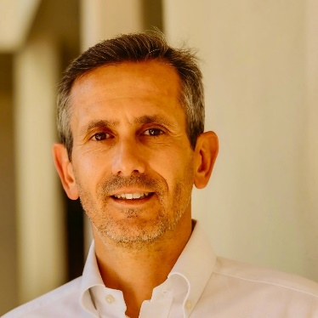

Stefano Pardi, PCC, CPQC, MBA
Consultant and Coach

Based in the UK, Stefano facilitates, trains and coaches in
English and Italian

Profile
A certified professional coach and management advisor, Stefano has over 20 years of international leadership experience in general management, strategy, marketing, product, sales and business development at high-growth global organisations, including Meta, Amazon, Expedia, American Express, Deloitte, and startups. Stefano has extensive direct experience building highly successful and engaged teams and businesses during times of high ambiguity and change.
Stefano believes everyone can unlock their full potential and has supported business leaders and their teams to build a sustainable and scalable path to high performance. Stefano helps his clients clarify and align their personal and professional goals with their values, defining strategies that build on their strengths and then taking meaningful actions to achieve their objectives. Stefano leverages the latest findings in coaching, neuroscience, positive psychology and his experience working in fast-paced multicultural organisations and sport coaching.
Stefano holds an MBA with Distinction from London Business School and a BA in Business and Economics from Luiss University in Rome. Stefano is a Professional Certified Coach with the ICF, graduated with distinction from the Coaching Academy, is certified in DISC profiling, is a certified Executive & Team Coach with Marshall Goldsmith (Stakeholder Centered Coaching), and is a Certified Positive Intelligence Master Coach (CPQC). Stefano also trained in Brain-Based Coaching with the Neuro Leadership Institute and is reading for an MSc in Applied Positive Psychology with the University of East London.
In his spare time, Stefano is a professional Triathlon coach who competes in Ironman and marathon races
Specialist Areas of Expertise
- Building and leading High-Performance Teams
- Commercial Performance Improvement
- Change Management
- Conflict Management
- Leading Remote Teams
- Coaching Skills
- Communication and Presentation Skills for Managers
- Culture Development
- Diversity and inclusion
- Personal and Team Productivity
- Executive presence and personal branding
- Customer Success

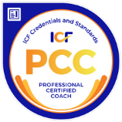
Profile: Stefano Pardi, PCC

Stefano has a successful track record in delivering
- 1:1 leadership coaching
- Facilitation on Building and developing high-performing teams
- Building Confidence, Empowerment, Motivation
- Vision and strategy definition
- Personal Branding
- Mental fitness
- How to become a “Corporate” Athlete
- Advisory on Vision & Strategy definition (including defining and monitoring OKRs)
- Developing a growth-led organisation
- Implementing a business experimentation mindset
- Developing winning Customer Success teams
Testimonial
“I highly recommend Stefano as an executive coach. I have worked with him for one year and have seen firsthand the positive impact he has had. Stefano is a skilled coach with significant corporate experience, where he has helped professionals understand context, plan structurally, and achieve their goals. He is a compassionate and supportive listener who creates a safe and supportive environment for growth and learning. I would not hesitate to recommend Stefano to anyone who is looking for a coach.”
Regional Head, Global Tech Organization
Corporate Experience
Stefano has worked across several industries and geographies, including technology, financial services & fintech, Management Consulting
Education & Training
- Professional Certified Coach (ICF)
- Master Coach Positive Intelligence
- Certified Positive Intelligence Coach (CPQC)
- Brain-Based Coaching, Neuro Leadership Institute
- Certified Executive and Team coach, Marshal Goldsmith Stakeholder Centered Coaching
- Certified DISC Profiling, Licensed Trainer
- Diploma in Personal Coaching, with distinction. The Coaching Academy
- MBA with Distinction, London Business School
- BA in Business & Economics, Luiss University in Rome
Memberships
- Member of the International Coach Federation (ICF)
- Member of the British Triathlon Federation
Volunteering
Mentoring and Coaching for various start-ups, universities

