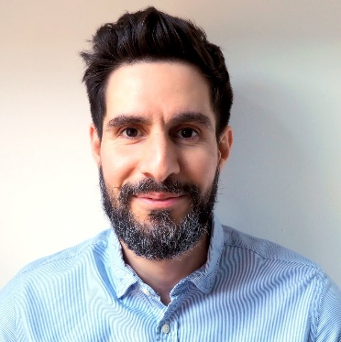

Dr Tarek Jomaa: FloL, SFHEA

EMCC Accredited Senior Practitioner
Consultant, Coach and Mentor
Based in the UK, Tarek facilitates, trains and coaches in English,
French, Italian and Arabic and also speaks basic Spanish.

Profile
With a unique blend of leadership expertise in motorsport, engineering, higher education, and business coaching, Dr. Tarek Jomaa is a highly sought-after consultant, mentor, and coach. He specialises in raising awareness among leaders and challenging them to overcome barriers, making him an invaluable asset for clients aiming to achieve new levels of success.
Dr. Jomaa's impact extends far beyond one-to-one coaching. He has revolutionised the motorsport engineering curriculum at the University of Derby, bringing about significant transformations. His innovative approach includes embedding coaching within leadership and teaching in higher education. These remarkable contributions have earned him prestigious Senior Fellowship of Advance HE (SFHEA) and recognition as a Fellow of the Institute of Leadership.
As a dedicated volunteer for EMCC UK, Dr. Jomaa plays a pivotal role in co-leading the Special Interest Group in Higher Education to explore how coaching and mentoring can benefit the sector. Additionally, he serves the EMCCUK as its deputy director responsible for the professional development of coaches in the UK. Notably, Dr. Jomaa has created his own coaching model and developed the "5A leader" concept, which mentors leaders to lead with awareness based on the five awareness pillars.
Whether in a technical or coaching capacity, Dr. Jomaa's expertise is unparalleled. His extensive knowledge and experience make him the ideal professional to challenge leaders, enhance their self-awareness, and empower them to achieve extraordinary success. By choosing Dr. Tarek Jomaa, clients gain access to a unique set of skills that blend industry-specific insight with transformative coaching methods.
Specialist Areas of Expertise
Women in Leadership, Leading High Performance Teams, Leading with Uncertainty, Transformational coaching, Academic coaching, Negotiation Skills, Change Management, Decision making, Motivation, Performance Management, Advanced Facilitation Skills, Conflict Management, Remote Management, Coaching Skills, Communication Skills for Managers, Diversity & Inclusion …
Dr Tarek Jomaa has a successful track record in delivering
- 1:1 Leadership Coaching
- 1:1 Executive Coaching
- Confidence, Empowerment, Motivation
- Leadership Development and Mentoring
- Career Development
Testimonial
“Tarek’s guidance has been instrumental in my journey, and I am grateful for his continued support.”
Rabih Hamid, Product Development Engineer, TDI BV
“Dr Jomaa’s coaching sessions are a game changer.”
Michael J Sweet, Professor of Molecular Ecology and Head of the Nature-based Solutions Research Centre at University of Derby. Co-founder of the Coral Spawning Lab.
“Tarek has been invaluable in many delicate situations in the life of an entrepreneur.”
Marc Evenisse, CEO et Président Furion & Président Le Mans Tech.
Corporate Experience
Tarek has worked across a range of industries, including engineering, startups, higher education, e-commerce and retail.
Education & Training
ILM L5 Diploma in Effective Coaching and Mentoring and apprenticeship
EMCC Global Accredited, at Senior Practitioner Level, Coach and Mentor - EIA20221745
PGCert HE learning and teaching from University of Derby
Higher Doctorate Level 10 NFQ Industrial engineering from The University of Padua
Master’s Degree Level 9 NFQ Advanced Automotive Engineering from ISMANS, Le Mans France
Honours Bachelor’s Degree Level 8 NFQ Mechanical engineering from Lebanese University
Memberships
- Member of the European Mentoring and Coaching Council (EMCC and EMCCUK)
- Fellow member of The Institute of Leadership
- Senior Fellow Member of the Advance HE (SFHEA)
- Fellow Member of the Advance HE (FHEA)
Volunteering
- Deputy Director of Professional Development | EMCC UK, UK
- Special Interest Co-Lead and facilitator | EMCC UK, UK
- Leadership accredited Mentor for The Institute of Leadership, UK

