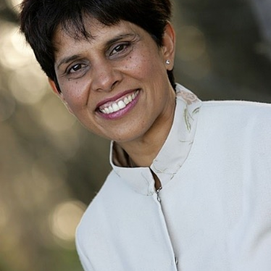

Yvonne McLean BA PCC
Consultant, Coach & Faculty Member

Based in New Zealand, Yvonne consults and coaches in
English and German. She also speaks Proficient French
and elementary Portuguese and Spanish

Profile
Yvonne is passionate about supporting people in organisations to grow as leaders and to build a sustainable values-driven corporate culture. As a coach, she supports her clients by providing a safe space to reflect and grow, guiding each person towards achieving their successful outcomes.
Yvonne combines her previous experience as a lawyer in private practice and a senior executive in corporate to work with senior business leaders and professionals across the globe, especially in New Zealand, Asia and further afield. Yvonne works primarily with people in leadership positions (individuals and some teams) as an external leadership coach, team coach and facilitator. She was the founding Programme Director for the NZ Global Women, Women in Leadership Initiative, and was responsible for developing its original highly successful Breakthrough Leaders’ Programme. Yvonne has since developed and led successful women in leadership and general leadership programmes for corporate and public-sector clients. She also works with leaders in many organisations to develop their emotional intelligence and coaching capability.
Specialist Areas of Expertise
- Leadership generally, especially women in leadership
- Building self-confidence
- Negotiation Skills
- Coaching Skills
- Emotional Intelligence .
Yvonne has a successful track record in delivering
- Performance Management
- Conflict Management
- Communication Skills for Managers
Testimonial
“I had the pleasure of working with Yvonne as my leadership coach for 6 months. Yvonne has a great style that quickly put me at ease and had an amazing ability to get to the issues quickly and she really challenged my thinking. The goals we set together at the start if my coaching have well and truly been met and Yvonne has given me a great set of tools to continue to develop and challenge myself in my professional career.” (Lisa North, Sales Director, NZMP, Fonterra)

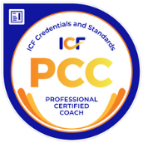
Yvonne McLean BA PCC
Corporate Experience
Yvonne has worked across a range of industries, including the humanitarian sector, accountancy and law, aviation, banking and finance, insurance, manufacturing, FMCG, government, health, construction, energy, pharmaceutical, dairy, telecommunications and retail.
Education & Training
- Professional Certified Coach (ICF)
- In the process of completing accreditation as a Leadership Circle Practitioner
- Training as a Coaching Supervisor – with the Forton Group
- Licensed Facilitator: Tara Mohr – Playing Big
- Completed Brené Brown - Daring Greatly Programme
- Accredited GENOS Emotional Intelligence Practitioner
- mBit Coach Training certification
- Attending the FORTON Group COACH’s WAY Programme and preparing for application for ICF PCC Credential
- Completion of the FORTON Group DEVELOPING and ADVANCED Leadership Coaching Programmes
- Licensed Facilitator of the FORTON Group IGNITE Leadership Coaching Programme
- Licensed Facilitator of the Coach U Essential Conversations for Developing Others
- Licensed Facilitator of the Coach U Coaching Clinic ®
- Graduate - Core Essentials Coach Training with Coach U/Coach Inc
- Certified Professional Behaviour Analyst, using the DISC Assessment tool
- Certified NLP Practitioner, certified by the NLPTRB
- Trained in mediation by LEADR (Australia)
- Admitted to the New Zealand Bar as Barrister & Solicitor
- Admitted as a Solicitor of the Supreme Court of England & Wales
- College of Law, London : Common Professional Exam (to convert Arts Degree to Law Degree equivalent) and Solicitor’s Final Exams
- University of Oxford, England : BA Hons in Modern Languages
Memberships
- Member of the International Coach Federation (ICF)
Volunteering
Yvonne has been an active member within the leadership of the International Coach Federation (ICF) Australasia Chapter. She started as a member of the NZ Northern Branch leadership team in 2006, and served as a team member at large, the Events Coordinator, Branch President of NZ Northern Branch for 2 years and joint President for one year until November 2012. She was NZ Director on the ICF Australasia Board November 2012 - November 2015.

